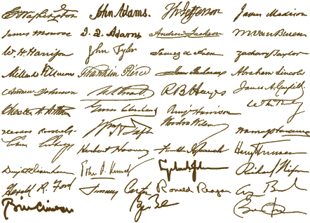

Dear,

Goods for the Woods

I have written this letter to you to ask for a simple request. To start stocking beanbag rounds. Under this letter are 75 people that would love to be able to buy beanbag rounds locally and would like to buy them from you. This could be a big market for you because most people don’t want to shoot a bear because it is illegal and people don’t want to hurt bears. Because of this many people have heard about beanbag rounds but don’t want to order them off the Internet. It would be a big help to start supplying these rounds at your store.

Sincerely,

Zach Flora